

Creative Geelong Co-Op platform

Project Handover Document

Team 12A

Date: 27 – May-2018 -T1

**table of contents**

**Project Client** **3**

**Project Contact Person** **3**

**Project Mentor** **3**

**Project Team_12A** **3**

**Document Purpose** **4**

1.Initial proposal: 4

2.Plans: 4

3. Status reports: 4

4.Sprints report 5

5.reflection 5

6.key open issues 5

7.assumptions 5

8.vision of future sprints 6

**Project Description** **6**

Description 6

Aim 6

**Business Features** **7**

Approved features by client 7

Implemented features 7

InProgress features 7

sprints and due dates 8

**Planned work** **9**

**Open issues** **9**

**Lessons Learned** **10**

**High-level architecture of the product** **10**

**Source code** **11**

**User manual** **13**

**Other relevant documents** **14**

List of all software/tools 14

B. Teamwork 15

**Appendices** **18**

Sit374_project handover_team12A

# Project Client

The project client is Creative Geelong headed by Jennifer Cromarty and Adam Lloyd.

# Project Contact Person

> Jennifer Cromarty ([hello@creativegeelong.com.au](mailto:hello@creativegeelong.com.au))

> Adam Lloyd ([adam@itevolved.com.au](mailto:adam@itevolved.com.au))

# Project Mentor

Dr. Justin Rough

# Project Team_12A

|  |  |  |
| --- | --- | --- |
| **Student Id** | **Student Name** | **Role** |
| 215 108 095 | Dominic Eames | Team leader/Database developer |
| 215 358 779 | TAO GE | Web development |
| 215 392 074 | Chengzu Dong | UI design/business analyst |
| 216 024 733 | Marial Machut | Security analyst/web developer |
| 215 432 814 | Muhammad Zumair Qureshi | UI Design/ Web Developer |
| 215 082 665 | Christiane Smith | Back-end security dev |
| 215 126 329 | Ziran Chen | Back-end security dev/ business analyst |

# Document Purpose

This document records the transfer of all the information and artefacts produced during the course of this project in the first phase. The handover document and delivery package includes the following:

## 1.Initial proposal:

This project involves creating a functional website for Creative Geelong. Similar to eBay, users and clients are able to buy and sell products. Implemented within the website are different functions and user interfaces so admins, users, and customers are able to obtain a certain level of control in accordance with their needs and user level. This site allows users to search and browse the seller's merchandise where there is a shopping cart function allowing users to buy multiple products from different vendors. In terms of website security, WordPress implements its own security measures and many plugins are available to combat many online threats. Secure payment methods will be used including PayPal. Security will also include, ensuring data is validated and sanitized, no personal or sensitive data will be stored within the website, and ensure no passwords or sensitive information is stored in plain text. In several key functional areas. Clients will be based within Victoria as it is aimed at engaging local communities around Geelong. Additionally, the website will also provide users with the latest information and events hosted around Geelong by clients and their users.

## 2.Plans:

* UI design plan, including sitemap, UX design (wireframe) (Sprint 1)
* Ensure all security aspects have been spoken about and detailed including login security, payment security
* Create an attractive website that is able to be easily navigated with appropriate information and content viewable in browsers. In addition, it will be a responsive website meaning it can be used on different devices e.g. mobile, tablet etc. (Sprint 2)
* Databases connected to website, which can be queried by search function. (Sprint 2)
* Account Creation and login using database. Security involves but is not limited to not having the password in plain text, password requirements (at least 8 characters, special characters, capital letters), and where the user’s usernames stored an encrypted version of the password will be kept helping counter-intrusion. (Sprint 2)
* Working shopping cart using cookies. Payment purchases can be paid securely via credit card or option to pay cash. (Sprint 2)
* Editable client page/s that will allow client to upload their products on the website. (Sprint 2)

## 3. Status reports:

our website has partially completed the overall design work. For example, Sitemap, UI design, security and functions. The website has completed all the ideas. The structure and development process is also very clear. In some important parts, we have also communicated with our mentors and clients. And getting feedback and modification. Now we have reached major steps that indicate the 70% success rate of the project. the website is currently functioning on WordPress and we are in customization stage until the last step of development. We gathered enough themes for the project and we are to focus on different plugins especially security plugins, we will make some prototype demo for the clients in next meeting.

## 4.Sprints report

* For Sprint 1, we have completed the design and layout aimed to be used for Creative Geelong's official website. Our client was impressed with the designs created by our team and we have addressed the feedback given in order to create a website fit for Creative Geelong. We have also created a sitemap detailing the structure. In addition, we have clear outlines on what we wish to complete for sprint 2. The sprint 2 plan involves designing and creating the features that we have mentioned in our proposal so we can implement them in our site.
* For sprint 2, we have selected WordPress as the developing tool and platform to facilitate us. We would like to match the real website with the designed website UI. And we will try our best to deliver the well-built website to our client during this Sprint.

## 5.reflection

In the process of project development, there are some problems and areas for improvement. We have reached some complications in UI design and website functional design. We have always believed that a good website requires a simple and efficient access process. Allows users to solve their own problems efficiently. This is also the original intention of our website. We hope that in the subsequent development process, the development of the website will be more efficient and more colorful.

## 6.key open issues

* Team Time Management: As in the week 1 we had issues with the meeting timings as we all had our work and other assignments to work on. As we all had to decide the timing and day of the team meetings. It was hard to decide the timing of the client and supervisor meetings as we need to be flexible with the other team 12B as this meeting were together on different days. As a result, we need to manage the timings and to stick to a timetable for our project so we can get our project done on time.
* Design: We made website designs on paper first and implemented on illustrator. It was hard as many issues raised on design as we need perfect one for the client so we made 3 layouts and one of the issues were layout colors and the fonts in the footer were not clearly visible as we did not apply the correct color code for the footer and fonts in it. UI menu was a problem as there was an issue with the assuming if the client wanted more categories in the menu so layout has to be the same and to make it easy UI we made a hard decision on it.
* Security plugins: The team did their best to get best plugins for the website so it took a lot of effort and research for the security team to deal with it, and it was an issue as we needed our plugins to be decided as soon as possible so that the development team could work on the website as the security team came up to a very reliable plugin which has benefited the website.

## 7.assumptions

* Design: we will design the real website to match with our previous designed UI. And if the client needs to add anything to the category, we would like to improve the website for our shareholder. And we will pay more attention to the interaction of color. Which is very important and we made the mistake in Sprint 1 because using unclearly background color with fonts in our footer of the website.
* Security plugins: we will deploy/integrated the best Security plugins that dealt with all sort of cyber threats/scams/spams and cross-scripting on Creative Geelong website
* Database crash: assuming it can fail, as a server down so we need to have backups so that we can run it when the main database is down.

## 8.vision of future sprints

Sprint 3: By the end of sprint 3 we would have like to be able to ensure we can add example users/clients to be able to buy and sell products using the website as a platform to do so.

Sprint 4: By the end of Sprint 4, we would like to have created a fully functional website for Creative Geelong to use. We would like to be able to have fully implemented the characteristics that creative Geelong desire into the website

# Project Description

## Description

This project is about building an online store for Creative Geelong that will help the client and local Geelong's residents to sell their creative products and support local creative people. The website will provide clients space for them to list and sell their products online. The users and clients will have separate logins which lead to different controls that will allow users to search and browse through client’s products. Adding products to a cart where they can purchase more than one product at a time from different sellers. The website will also keep users up to date with all information from creative Geelong. Our research shows that  
 similar solutions already exist, e.g. eBay or gumtree, these solutions don’t specialize in creative products to sell on their websites, they have great search functions and the excellent way in promoting sellers which we really want to push on to our app but lacks that specialization we are after. Another great platform is Esty which is a place for small businesses or home creators to make and sell their products, we find the website is very messy and there is also a lot of bad products to be bought, we find the specialization is great but also doesn’t allow for such a specific region of where the products are from. Hence, creative Geelong website will be unique and users will be sellers from a local area in Victoria and all will have a similar goal of selling products they have created, the other type of user that will be using the solution will be buyers who are looking for a specific type of artwork or browsing and like to support local creative minds.

## Aim

The aims of the project are to reform the Creative Geelong website, and making an online store for Creative Geelong. The shareholders or clients will get a little percentage of profit from the products that they sold to maintain the platform running. And we listed detailed plans about how we will achieve the project aims during this trimester and we will try our best to deliver a well-built website to our clients as shown in our sprints categories below:

**Sprint 1 (weeks 5-8)**

* **Aim – the** aim of this sprint

1. Designing UX
2. Designing Site Map
3. Design UI
4. Making UI in Dreamweaver and implementing CSS.
5. Adding items to the website e.g. logo, images, and details of items.

**Sprint 2 (Weeks 8-12)**

* **Aim –** Aim of this sprint

1. Designing and implementing a working shopping cart.
2. Creating Databases (seller information, client information, order) that will hold the - Seller information (Name, ID, phone number, email address, location, home address, product, Product quantity, Product price)

- Client information (Name, ID, phone number, email address, location, address)

- Order information （Seller name, seller ID, client name, client ID. order number, Payment, Address ）

1. Pseudocode for login, account creation and payment. (includes sellers and buyers)

# Business Features

## Approved features by the client

- WordPress

- woo commerce

- Shopping Cart (Product Details)

- Layout

## Implemented features

- All approved features (WordPress, woo commerce etc.)

- Payment gateway and security

- pages (Contact us, Footer contain social media, Login and register pages)

- Theme (Dokan-lite)

## InProgress features

- security plugins, some need client approval

- whole web contents customization (making it clean and professional)

The Trello Board Screenshot samples

## sprints and due dates

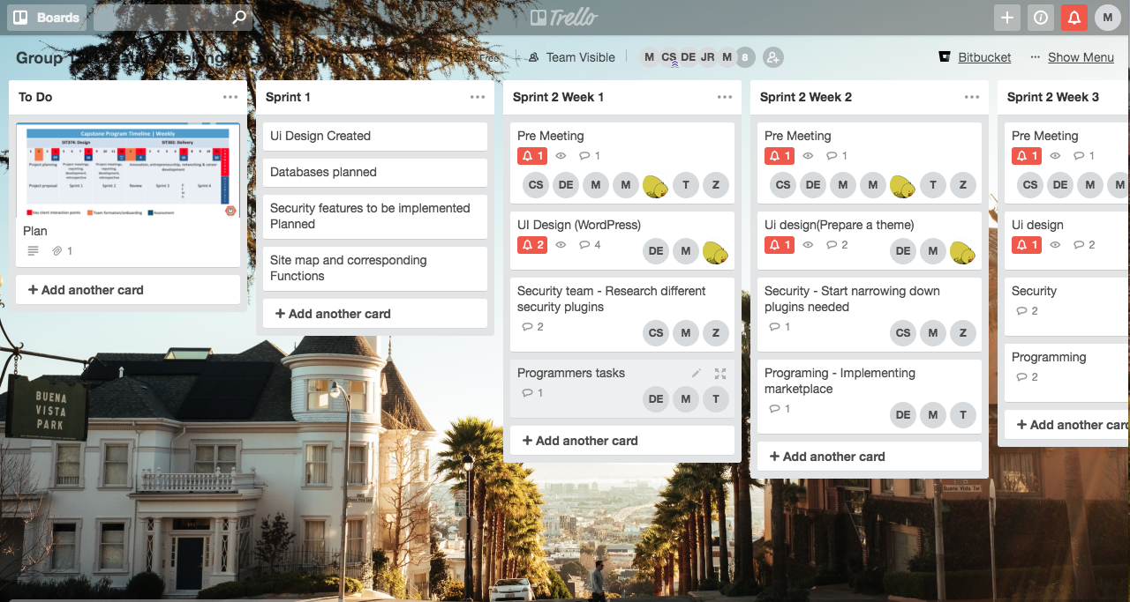

* **Meetings**

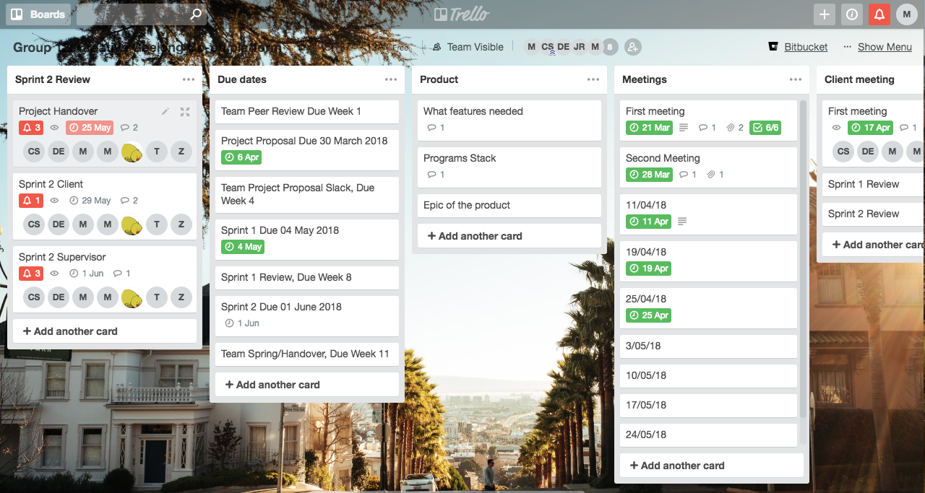

* **Programs**

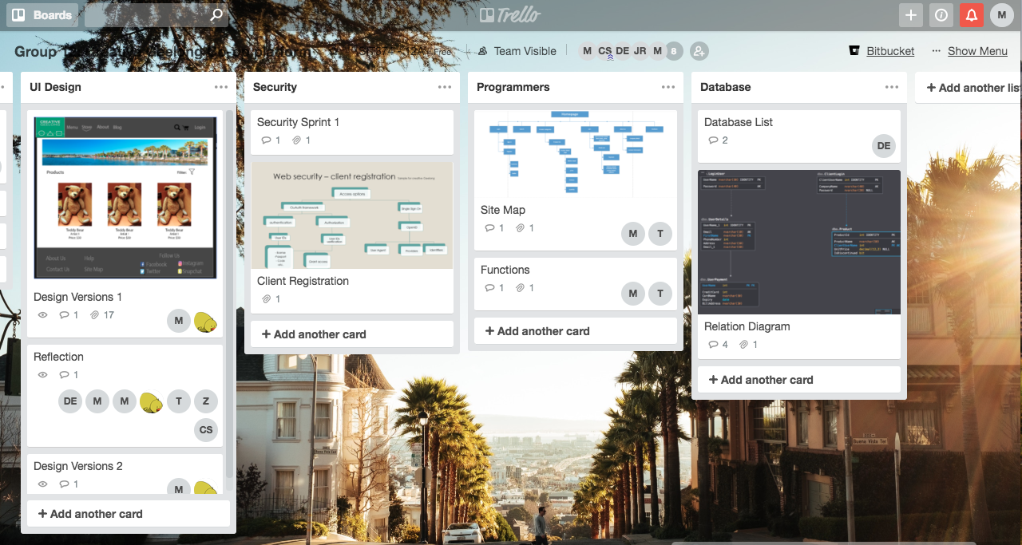

# Planned work

* the Small Business owner would like to have an online platform, so they can advertise and increase sale margins.  
  It is a necessity that the website is secure in terms of logging in, accessing the data and knowing that sensitive data is protected. This sensitive data includes login credentials, any files chose to store on client account and payment/credit details. It's also important that the website allows the client and other users to change their details and items they may be purchased with ease.
* At the Buyers point of view, they would like their account and any information given to the website to be secure. This includes creating an account where they have personal login details that members of the public or anyone without consent can’t see. they would also like to be ensured that their sensitive information such as payment details and address are secured. Additionally, they would like to easily be able to go through and see what items are available and items they have selected with an adequate amount of detail attached. When viewing the shopping cart, they would like to be able to view, delete, and add items with ease. And finally, when they wish to pay for their items, they would like to add and use their Credit Cards/ PayPal account easily and securely.
* for the Young Adult, they would like to be encouraged to make the most out of being creative. they would like to be provided with a platform that enables them to easily advertise and sell their products. At the end of the day, their aim is to sell and share work with as many people and would like to do so it the easiest way possible. they would like to reach as many people as they can and a space to do so where they can customize and give a personal touch.
* The core idea is to create a website, which will help buyers, and sellers to access a platform where they can look up items and sell them. The idea is also to make the easy user interface of the website.
* This website will give chance to sellers to sell their items and make money. The Buyers can get their wanted items from the website.

The Trello board link is <https://trello.com/b/iFXMbikc>

# Open issues

Please provide a detailed list of open issues/challenges in the project and any investigation that you have conducted so far.

* It is not easy to realize that moving our designed layouts to the real website.
* The secure payment is a huge challenge.
* Using Microsoft Azure with WordPress is a challenge because we never used this tool before. However, it is a very excellent platform.
* While using Microsoft Azure with WordPress application, the money that is given to students gets depleted very quickly while hosting the site. This caused the sites to only be live for a week or two at most. While this is an issue we have opted to locally hosting the sites on virtual servers but makes it hard for us to collaborate.
* Potential security risks could occur by using WordPress as the website contains great plugins, but they are paid so as a student we cannot afford it.

# Lessons Learned

The lessons learned by team 12A during creative Geelong project comprises of both negatives and positives experiences as illustrated in the following bullet points: -

* **Teamwork and many communication platforms**, throughout our project stages, we maintained a good level communication. Looking over the process we can see that when each team member was communicating and showing good commitment to the group work, it had a really positive impact, in turn speeding up the project tasks needed to be completed. Availability of different communication tools such as Slack and Skype have aided in being able to communicate effectively as a team. In each team meeting we are able to see that everyone is actively participating and contributing to discussion. Outside of team meetings slack and skype are still being utilised to ensure everyone is keeping up to date and that we are all involved in each process and happy with what's being done. These communication tools allowed our team to bounce off each other’s ideas and look at tasks from different perspectives. By utilising these tools, we were able to communicate efficiently and effectively and helped us complete our work to a high standard.
* **UI Design**, at the beginning of this project, our designers spent much of their time to figure out what design will match the client request and to meet the target, they have to produce multiple samples that required them to a learned new tool such as illustrator to develop and design a real website.
* **Web Contents or functions,** choosing web contents, themes and code writing from scratch were challenging duration sprint 1, after speaking to both parties (client and supervisor), we realized that using existing applications and software can give our team a better advantage to create a functional website. Fortunately, our client recommended the use of WordPress to develop the real website to make it works.
* **Tools usage**, the use of Trello to neatly organize all our documentation need an extra time to learn tutorial of how to use the tool compare to Slack and Skype which were fairly easy to use for our team communications. Though we have trello board with all our project records, it not professional organized as per supervisor statement during sprint 1 review meeting.
* **Client meetings,** there were few issues in regard to all team members meeting with a client on Google hangouts video chat, as there was a limitation to the number of attendees, some of our team members have to drop out or sometimes hard to join the call if a number of callers exceeded that limit. This was because client sometimes has to meet with two teams (12A and 12B) at the same time.

# High-level architecture of the product

* links to the creative Geelong

1. Quick video showing how you can walk through the website login and site access.   
   <https://drive.google.com/file/d/12h9AFtOtNpi7MLm0dChxm6Tx6fKr_N_c/view?usp=sharing>
2. the link to the Site: <http://creativegeelong.azurewebsites.net/>
3. login credentials: user = Admin and Pass = admin

4. Diagram showing the HLP of creative Geelong

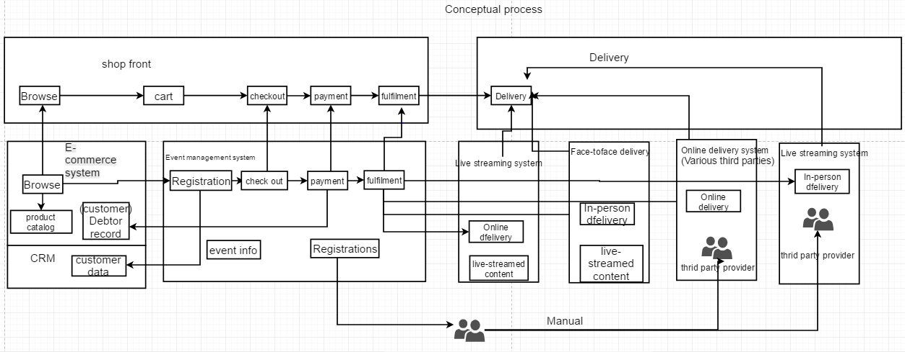

# Source code

We are using Dokan-lite as a theme for our website on WordPress.

As a result, we can only show the basic codes which are used to make our website, if you see the code it is all PHP files which have theme data is linked to the WordPress. WordPress is the platform on which the website is made and the theme can only be edited on WordPress platform.   
We will be making a video for codes. We have attached the source code folder to the drive [2]

Customer-Order Coding for the theme

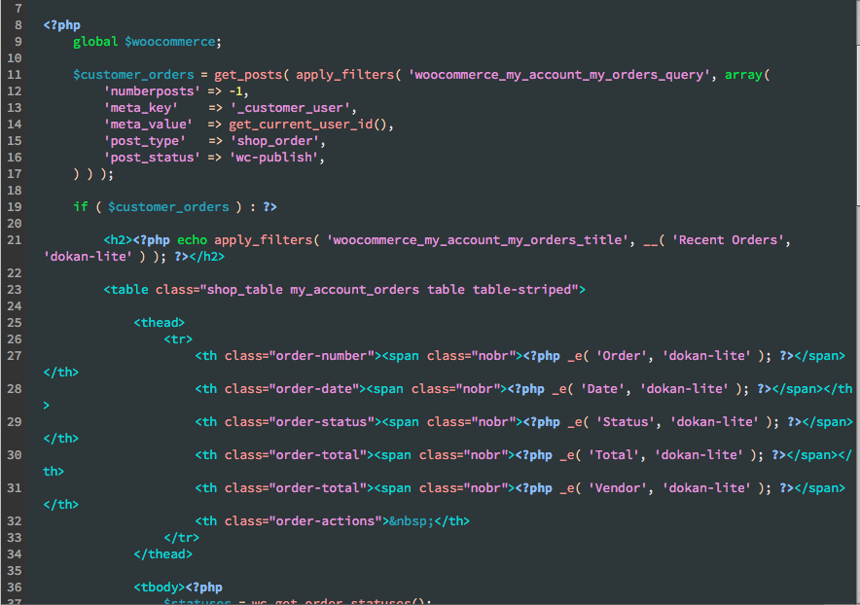

This screenshot shows a part of customer order PHP coding for the theme as it shows that the order is been shown in the table and the order, date, status, total, vender and also to take an act of the order to process or not.

Store Code sample

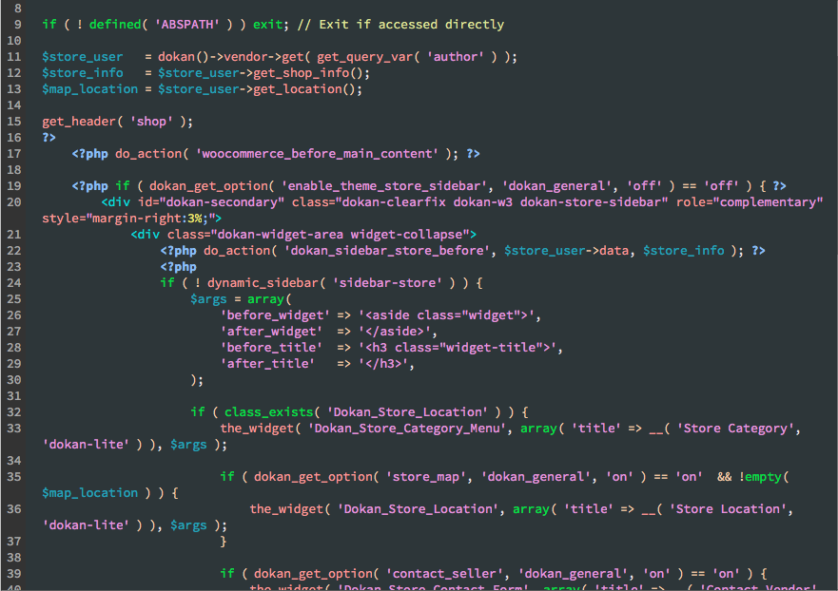

This screenshot shows store PHP coding which is about store sidebar which shows widgets. As also it shows the category menu and its titles. It also shows the store map.

Payment Code sample

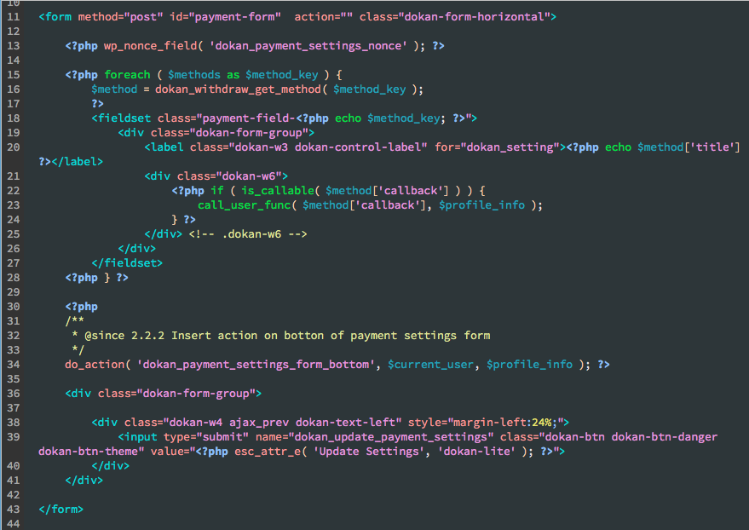

This screenshot shows about the payment PHP coding which helps to insert payment in the form to save it or update it.

Style Code in CSS file

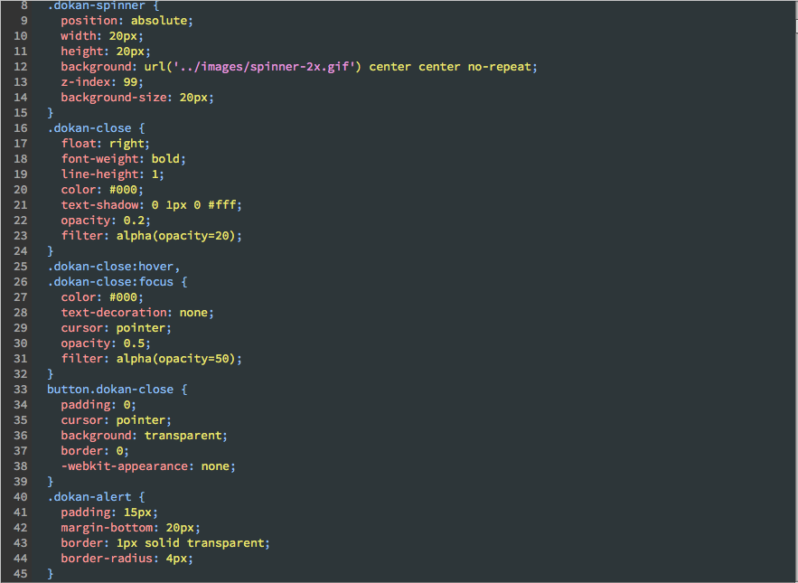

This is the CSS code for the style of buttons and alert. It tells us the padding, fonts, margin, borders etc. Types and their sizes which are used here.

There is more source code in Git Hub【4】:

<https://github.com/zee0701/CreativeGeelong>

# User manual

When the end user opens our website, the first thing they see is the home page. In the top, right hand corner they will see our register and login button. In order to register and create an account with Creative Geelong they must fill out a form which includes some personal details such as their name, email and address. Once they have registered with Creative Geelong, they are able to login and look at the shopping page. There are many products in the shopping page so to make the users experience more efficient we have implemented a filter and advanced search for users to find their favourite product in a timely manner.

After they've selected the products they wish to purchase they can click the cart function. Within the cart they will find the products that they have selected. They can edit the quantity of the product here and they can remove products if they do not want to continue to purchase them. After that they can click the Purchase button to finalise the payment. We have provided secured payment and we will ensure users personal and sensitive data such as address, phone number and bank details are secured and protected. We also have customer service to provide the service of refund or replace if needed. If the request of refund or replacement is approved, customers can send the product back and the refund payment will be given. Users can send the email to our email inbox and they can come to our store if they would like to talk with us face to face.

# Other relevant documents

## List of all software/tools

|  |  |  |  |
| --- | --- | --- | --- |
| **Software** | **Brief Description** | **Function** | Link |
| **Slack** | This is a platform where all members discuss the project on a daily basis | Communication | <https://slack.com/get-started> |
| **Trello** | Project management platform used for the task deadlines and roles which are given to the members | Task management  e.g. Deadlines and roles | <https://trello.com/login> |
| **GitHub** | This platform is used for uploading all the documents so that all members can access it | Development and Source Code repository | <https://github.com> |
| **Google Docs** | It is a platform for the members to edit any documents needed as a team. | Online editing Documents | <https://docs.google.com/document/u/0/> |
| **Skype** | Skype enables file transfers, texting, video chat and video conferencing. | voice/Video Meetings | <https://join.skype.com/Tuhc3kZTdHuO> |
| **Adobe Dreamweaver** | Adobe Dreamweaver CC is a web design and development application that combines a visual design surface known as Live View and a code editor with standard features | UI Design Development | <http://www.adobe-students.com/au/> |
| **Microsoft Azure** | cloud computing service | Hosting platform | <https://azure.microsoft.com/en-au/free/search/> |
| **WordPress** | WordPress is an online, open source website creation tool written in php. It easy to use and powerful blogging and website content management system use by many people. | Content management system (CMS) | <https://wordpress.com/>  Or  <https://wordpress.org/> |
| SharePoint | Share and manage content, knowledge, and applications to empower teamwork, quickly find information, and seamlessly collaborate across the organization | Online editing Documents  Similar to google doc | <https://products.office.com/en-AU/sharepoint> |

## B. Teamwork

This is a critical part of the project. This determines the success and failure of the project. Our team has always been efficient in teamwork. In this section, we will share some good experience in teamwork. These Suggestions are what we think will help us a lot. Our team USES three different tools for teamwork. Slack, Skype and Trello are among them.

**Slack**

This is a daily communication software for our team, and it is also the one we use most frequently. The daily communication of our team project and the negotiation of project issues are all conducted on this software. This software is very efficient in use. Users can timely give feedback to all or individual team members and share any information we feel necessary. In addition, it has helped the team in the inevitable problem of each team member not always being available at the same time. Because slack keeps a record of our conversation we are able to give updates on what was spoken about in each meeting. In the initial phase of the project, the weekly meeting time was determined using the voting function of slack.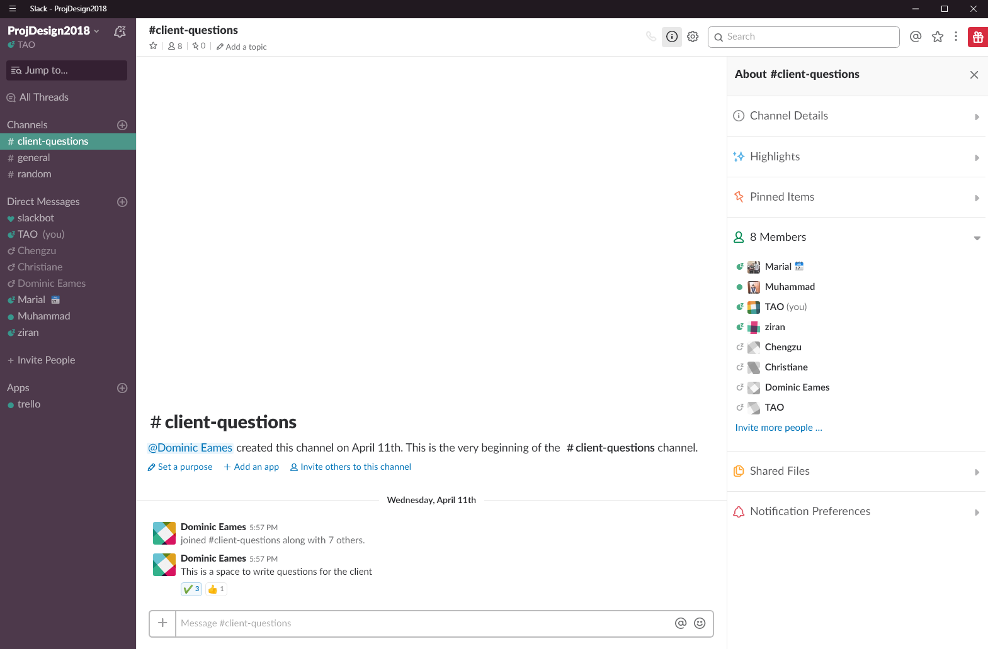

**Skype**

Skype is mainly used for weekly meetings. The weekly meeting time of our group is every Wednesday afternoon. The meeting with the mentor is every Friday afternoon. During the development of the project, we encountered a lot of different problems. These issues required our team to discuss them, and on important issues, we consulted with tutors using Skype. Communication is very important for teamwork which is why we utilise these tools as much as possible. The advantage of Skype is that after the establishment of the discussion room, each time the meeting begins, the team members can be notified in a timely manner.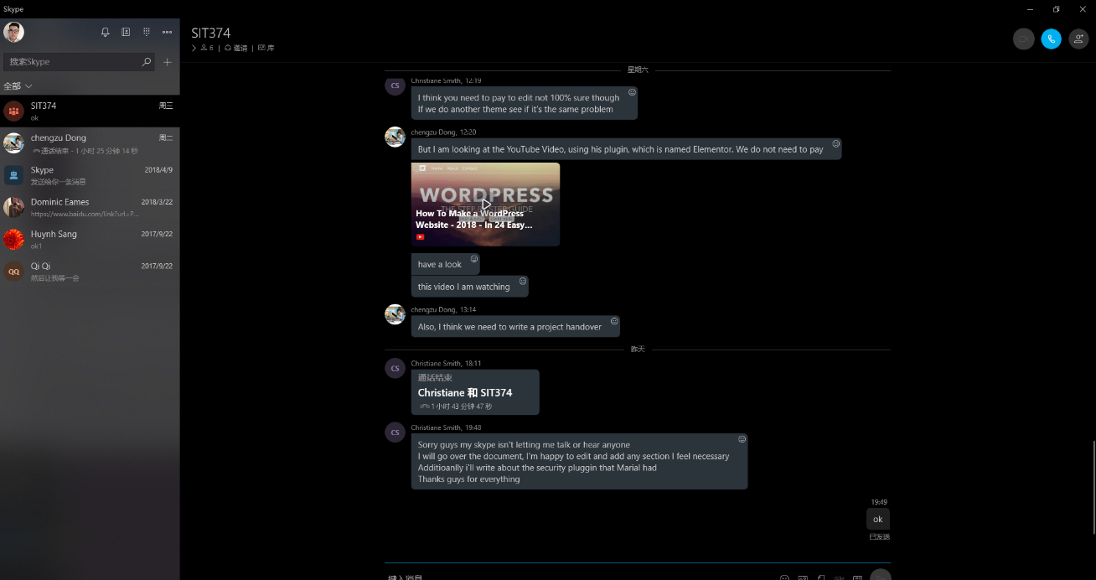

**Trello**

Trello's main role in team work is the division of labour and records. From the beginning to the end of the project, a tool is needed to record and control the entire process. Trello is used in every division of our team, where each division upload and store all relevant documents. Because, the completion of a project requires different parts to be pieced together, Trello gives us a great platform to see each piece coming together. Because everyone is responsible for different parts, each member uploads their work to Trello after each task is completed. In addition, team leaders can use Trello to clearly divide and record. It gives each team member a clear objective of each task and what needs to be completed. This in turn makes the entire project run efficiently.

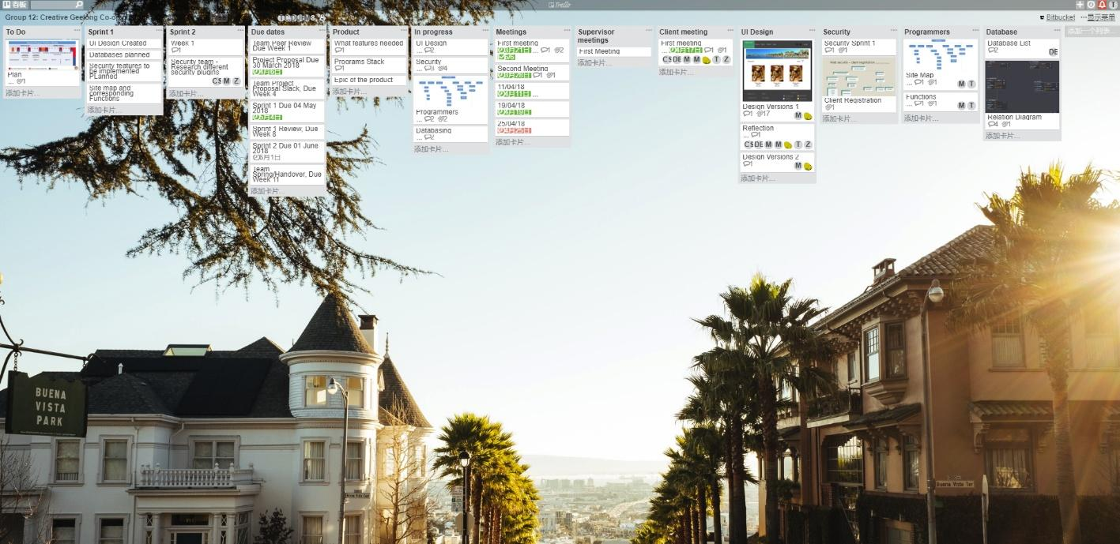

# Appendices

# 

[1]How to use WordPress. <https://www.youtube.com/watch?v=2cbvZf1jIJM>

[2] Source code:

<https://drive.google.com/drive/folders/1gWsS96nDc--GIw7oq9IeZtWJJpLGieEn?usp=sharing>

[3] Dokan themes

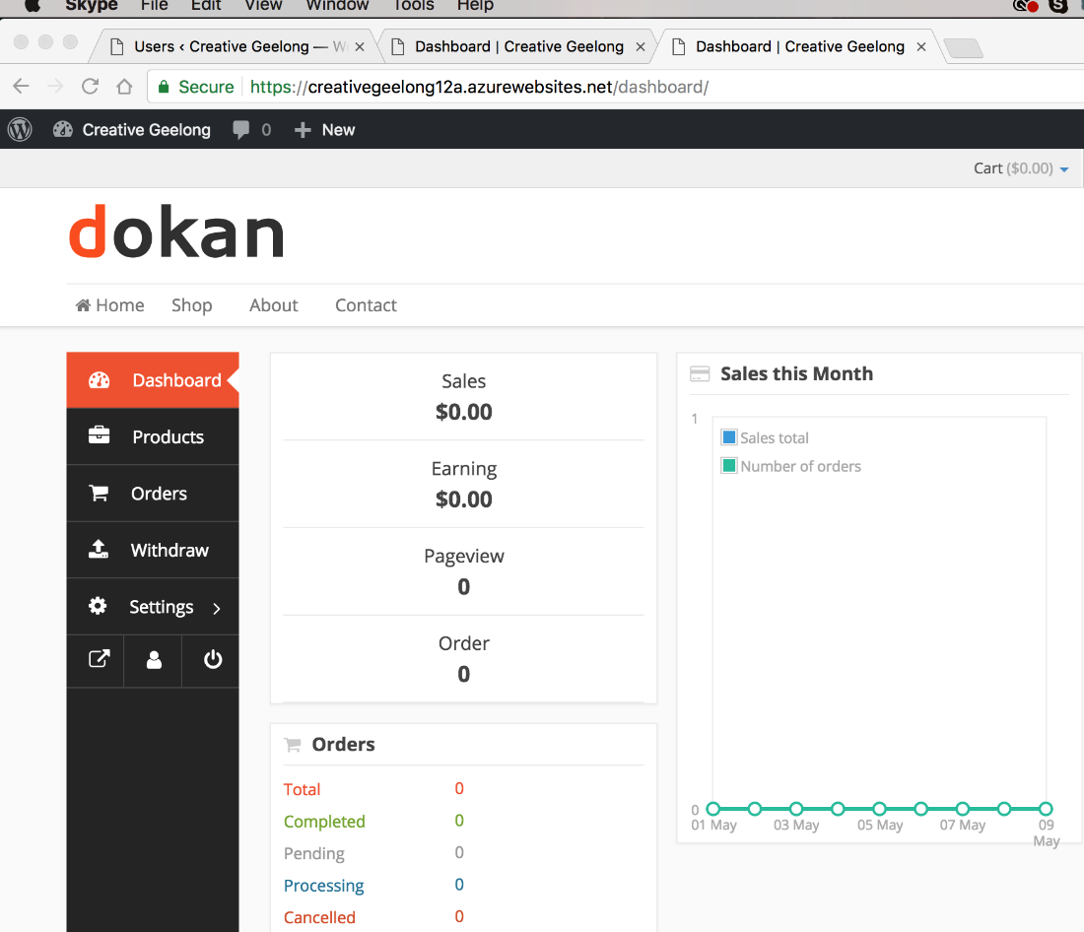

[4] Github link: <https://github.com/zee0701/CreativeGeelong>